SAMHSA’s BRSS TACS
Virtual Expert Resource Meeting
on
Supporting People with SMI or SUD in
Achieving Employment Goals

February 25–26, 2020

Expert Resource Meeting Report
April 16, 2020

Prepared for the
Substance Abuse and Mental Health Services Administration

CONTENTS
ACKNOWLEDGEMENTS 4
Disclaimer 4
Public Domain Notice 4
Originating Office 4
Contact Information 4
ABOUT BRSS TACS 5
About the Expert Resource Meeting 6
Meeting Objectives 6
Participants 6
Meeting Format 6
Key Themes 6
Summary of Proceedings 8
Discussion Themes 8
Employment should be a central focus of SMI and SUD treatment and recovery support—although it is not yet 8
People with SUD or SMI need a variety of employment services and support to achieve employment success 9
Help getting a job is not enough: employment programs should help people with SMI or SUD move out of poverty 10
Cross-system collaborations are key to improving employment outcomes 11
Making a paradigm shift from benefits first to employment first will advance both recovery and workforce participation 11
Employer partnerships are essential, and many employment support service providers are struggling to develop them 12
Treatment and recovery support providers and practitioners need more information about funding for employment services for people with SUD or SMI 12
Different stakeholders require different educational resources about the employment needs of people with SUD or SMI – tailored to their learning needs, professional roles, and work settings 13
Conclusion 13
REFERENCES 14
APPENDIX A: meeting participant list 15
APPENDIX B: expert Panel members’ biographies 18
APPENDIX C: MEETING AGENDA 26

ACKNOWLEDGEMENTS
This meeting report is the outcome of a collaborative effort among many contributors. The Bringing Recovery Supports to Scale Technical Assistance Center Strategy team offers special thanks to C4 Innovations staff and partners, especially Cheryl Gagne, Courtney Williams, Valerie Gold, Patty McCarthy Metcalf, and Binah Saint Loth for preparing, moderating, and implementing the Expert Resource Meeting on Supervision of Peer Workers. We are grateful to Maureen Madison, PhD, with the SAMHSA Center for Mental Health Services, and to Amy B. Smith, MA, LPC, SAP, public health analyst, in the Office of Consumer Affairs at the SAMHSA Center for Substance Abuse Treatment, for their guidance throughout all stages of this project. We extend our deep appreciation to the meeting presenters and participants for their commitment to increasing awareness of best practices in recovery supports.

Disclaimer
The Bringing Recovery Supports to Scale Technical Assistance Center Strategy (BRSS TACS) team, led by C4 Innovations, developed this report under contract number HHSS283201200035I/HHSS28342002T. The Substance Abuse and Mental Health Services Administration (SAMHSA), U.S. Department of Health and Human Services (HHS), supports BRSS TACS. The views, opinions, and content of this publication are those of the authors and do not necessarily reflect the views, opinions, or policies of SAMHSA or HHS.

Public Domain Notice
All material appearing in this report is in the public domain and may be reproduced or copied without permission from SAMHSA. Citation of the source is appreciated. However, this publication may not be reproduced or distributed for a fee without the specific, written authorization of the Office of Communications, SAMHSA, HHS.

Originating Office
Center for Mental Health Services and the Center for Substance Abuse Treatment, Substance Abuse and Mental Health Services Administration, U.S. Department of Health and Human Services, 5600 Fishers Lane, Rockville, Maryland.

Contact Information
Direct questions or comments related to this document to SAMHSA Contracting Officer Representatives Maureen Madison at (240) 276-1772 or Amy Smith at (240) 276–2892.

ABOUT BRSS TACS
Led by C4 Innovations (C4) and its partners, the Bringing Recovery Supports to Scale Technical Assistance Center Strategy (BRSS TACS) supports programs, systems, states, territories, and tribes as they implement effective recovery supports and services for children, youth, families, young adults, adults, seniors, and other diverse populations with mental or substance use disorders. The lived experiences of people in recovery, who play key roles in BRSS TACS project leadership, development, and implementation, enrich the work of BRSS TACS. In addition to C4, the BRSS TACS team includes these organizations:
- Boston University Center for Psychiatric Rehabilitation
- Community Catalyst
- Faces and Voices of Recovery
- Georgia Council on Substance Abuse
- National Association of State Alcohol and Drug Abuse Directors
- National Association of State Mental Health Program Directors
- National Council for Behavioral Health
- National Empowerment Center
- National Federation of Families for Children’s Mental Health
- New York Association of Psychiatric Rehabilitation Services
- Yale Program for Recovery and Community Health
- Youth MOVE National
The Substance Abuse and Mental Health Services Administration (SAMHSA) launched BRSS TACS in 2011. The SAMHSA Center for Mental Health Services and SAMHSA Center for Substance Abuse Treatment co-manage BRSS TACS. BRSS TACS serves as a coordinated effort to advance recovery, leveraging past and current accomplishments by SAMHSA and others. Through BRSS TACS and other efforts, SAMHSA supports high-quality, self-directed, and satisfying lives in the community for all people in recovery.

About the Expert Resource Meeting

Meeting Objectives
SAMHSA convened the Expert Resource Meeting (ERM) on February 25–26, 2020, using Adobe Connect Web conferencing software. The objectives of the virtual ERM were to:
- identify the vocational support needs of people with serious mental illness (SMI) or substance use disorder (SUD); and
- explore strategies to connect and coordinate existing programs, resources, and activities across systems and federal programs to improve the employment outcomes of people with SMI or SUD.

Participants
Participants came from 12 states representing all regions of the United States and bringing a variety of expertise. Panelists were researchers, employers, employment service providers, and recovery support specialists (see appendix A for panel members’ biographies).

Meeting Format
The virtual meeting structure featured plenary presentations along with breakout discussions and members giving reports to the entire group. Plenary sessions provided context along with updates on research and practice, while breakout sessions provided opportunities for in-depth conversations regarding employment supports for people with SMI, employment supports for people with SUD, and employment supports for people with criminal justice system involvement (the meeting agenda is in appendix B).

Key Themes
- Employment should be a central focus of SMI and SUD treatment and recovery support services—although it is not yet
- People with SMI and SUD need a variety of employment service and support to achieve employment success
- Helping a person get a job is not enough; employment programs should also help people with SMI or SUD move out of poverty
- Cross-system collaborations are key to improving employment outcomes
- Making a paradigm shift from benefits first to employment first will advance both recovery and workforce participation
- Employer partnerships are essential, and many employment support service providers are struggling to develop them
- Treatment and recovery support providers and practitioners need more information about funding for employment services for people with SUD or SMI
- Different stakeholders require different educational resources about the employment needs of people with SUD or SMI – tailored to their learning needs, professional roles, and work settings

Summary of Proceedings
The meeting began with a welcome address by Amy Smith, public health advisor at the SAMHSA Center for Substance Abuse Treatment, followed by the introduction of meeting participants and BRSS TACS staff. Cheryl Gagne, senior associate at C4, moderated the meeting and oriented the panelists to the proceedings over the next 2 days.
Each day began with a plenary address by a subject matter expert. On the first day, Robert Drake, MD, PhD, gave an overview of the Individual Placement and Support (IPS) model of supported employment. Dr. Drake presented research outcomes in a variety of environments and with a diversity of research participants, highlighting recent randomized trials among people with SUD. He described modifications to the IPS model for its use with people with SUD; other chronic health conditions, including pain; criminal justice involvement; and those applying for the Social Security Disability Insurance program or the Supplemental Security Income program due to illness or disability.
To set the tone for the second day of the proceedings, Gary Shaheen, PhD, delivered a presentation titled Establishing Partnerships with Employers and Other Community Resources to Support the Employment of People with SMI or SUD, which described many examples of partnerships that improve career opportunities for people with SMI or SUD and emphasized the need to help people find jobs that pay living wages.

Over the course of the 2 days, panelists participated in plenary sessions and small breakout group discussions to explore topics in greater depth. Plenary sessions included presentations and discussions among the entire panel. The meeting ended with a final plenary session where each panelist made key recommendations.

Discussion Themes
This section highlights the key themes and panelists’ recommendations that emerged over the 2-day meeting.

Employment should be a central focus of SMI and SUD treatment and recovery support—although it is not yet
Most treatment and recovery support service providers and practitioners do not focus on the central role of employment in the recovery of people with SMI or SUD. Treatment and service providers and practitioners address symptom management and health needs, but they may not know how to explore an individual’s employment needs or access resources to support workforce participation. In addition, there are often conflicts between employment and clinical services that have limited hours for people employed full-time. While many SUD treatment organizations offer services in the evening and early morning, these services are not universally available, which means that many individuals must choose between treatment or employment. With few exceptions, peer-run and recovery community organizations do not emphasize employment for their members and do not typically collaborate with employment service providers. One shining example of a recovery community organization providing employment support is the Connecticut Community for Addiction Recovery employment program, Recovery-Oriented Employment Services (ROES), in Hartford. ROES provides individually tailored employment support to assist people achieve their employment goals.
There is a need for increased attention on employment measures as a critical recovery outcome for people with SUD or SMI. For example, the Interdepartmental Serious Mental Illness Coordinating Committee does not currently attend to employment outcomes for people with SMI. At the same time, there are a few treatment models—such as first episode psychosis programs—that integrate employment and educational needs into treatment goals.

People with SUD or SMI need a variety of employment services and support to achieve employment success
Panelists recognized that because of the diversity of individuals’ strengths, needs, and circumstances, services need to be flexible. Factors that influence a person’s employment service and support needs include age, education, culture, employment experiences, socioeconomic background, co-occurring health conditions, and employment goals. For example, young people may need career exploration services, supported education and job placement, as well as support to launch a career that provides a living wage.
Panelists applauded the evidence-based IPS supported employment approach because it succeeds at rapid job placement with support. Work experiences help individuals shape their career goals and direction, and IPS is a proven model for helping people get and keep jobs. At the same time, panelists noted that IPS is not the best model for everyone, and some individuals may need different approaches to achieving employment success. For example, some young adults benefit from supported education, while others find success through models that support entrepreneurship.
Panelists discussed models of supported education and recognized the need for supported education services for young adults with SMI or SUD. There are several campus-based programs in colleges and high schools that coordinate wraparound services. These campus-based services and supports are not universally available, however, and many students do not receive the coordinated services they may need. Education and training lead to employment and higher paying jobs.
Panelists also acknowledged that accessing and coordinating employment services, as well as other recovery support services and high quality treatment, continue to be difficult for many people. Those with SMI or SUD often need treatment and recovery support services over the course of many years. Panelists described siloed systems of service provision with little coordination among organizations. The panelists made several recommendations for treatment and recovery support services to better serve people with SMI and SUD overall, especially in pursuing their employment goals:
- Improve integration of mental and substance use disorders at the system and program levels.
- Address the social determinants of health that prevent people from working. People with SUD or SMI may be experiencing barriers to employment such as homelessness, poverty, or health conditions, and treatment and service providers and practitioners need to help people address their basic needs.
- Facilitate cross-training and network development to educate—
- treatment providers and practitioners about the importance of recovery support services for people living with SMI or SUD;
- recovery support providers and practitioners about the importance of employment services; and
- employment service providers about the needs of people with SMI or SUD.
- Connect all providers and practitioners with current information about community resources and pathways to help people access these services.
- Explore diverse models of employment services, including entrepreneurship and career counseling.
- Establish evaluation methods to assess the effectiveness of different approaches to supporting employment among different populations.
- Continue expanding opportunities for supported education services.
- Reduce barriers for people with SMI or SUD in accessing employment support services.

Help getting a job is not enough: employment programs should help people with SMI or SUD move out of poverty
While the panelists were very positive about the effectiveness of IPS supported employment, they acknowledged that most jobs obtained are low-paying. Many individuals find it difficult to achieve self-sufficiency on low-wage jobs. Panelists emphasized the importance of supporting people with SMI and SUD to achieve financial self-sufficiency through employment and made the following recommendations:
- Teach financial literacy to help people manage money and benefits.
- Advocate for underserved populations by providing education and employment support services.
- Orient conversations about employment toward recognizing the distinctive needs of various populations living with SUD or SMI and that one model will not serve the needs of all people.

Cross-system collaborations are key to improving employment outcomes
Panelists highlighted the importance of cross-system collaboration and partnerships to improve the employment outcomes of people with SUD or SMI. There are many state or federally funded training programs that could benefit people with SUD or SMI. Multiple federal agencies, including the Department of Labor, the Department of Education, the Department of Agriculture, the Department of Housing and Urban Development, the Department of Veterans Affairs, and the Administration for Children and Families all fund employment services that serve people with SMI, SUD, or both. At the local level, many of these programs provide similar services and target the same industries and employers, often with little coordination and with limited awareness about what others in their community are doing. Providers and practitioners need access to information about these potential resources. Panelists made the following recommendations:
- Learn about available resources and programs offered through various federally funded programs.
- Create cross-sector partnerships at the local, state, and federal levels.
- Develop a national online repository for information and resources related to employment for people with SUD or SMI.

Making a paradigm shift from benefits first to employment first will advance both recovery and workforce participation
Panelists were enthusiastic about the Employment First movement as an approach to employment services for people with SMI or SUD. Research suggests that the sooner individuals begin work after the onset of illness, the more likely they will be working years later (Drake & Bond, 2008). Many people with SMI or co-occurring conditions are encouraged to apply for Social Security disability benefits rather than engaging in employment support services. Panelists described situations where lawyers told people not to work or engage in employment services so that they would be more likely to qualify for disability payments.

Since 2014, the U.S. Social Security Administration (SSA) has conducted demonstration projects at 40 different SSA offices to engage people denied disability payments in employment services. People may participate in employment services instead of appealing the decision or during the appeal process. The application and appeal process can take up to 2 years, which provides an opportunity for individuals to engage in employment services.

Panelists made these recommendations regarding Employment First:
- Provide benefits counseling to people applying for disability benefits so that they can assess the financial and other benefits of employment.
- Identify financial and benefit disincentives that continue to pose significant barriers in many parts of the United States and work to eliminate these disincentives.
- Increase awareness of options that mitigate financial and benefit disincentives. For example, in Medicaid expansion states, people with SUD and SMI can access health insurance if their employer does not offer health insurance.
- Engage people with SMI or SUD who are applying for disability benefits in motivational discussions about employment.
- Continue to develop strategies that offer people with low-wage jobs the opportunity to purchase health insurance.
- Promote the Employment First philosophy among treatment and recovery support providers and practitioners as well as people living with SMI or SUD and their family members.

Employer partnerships are essential, and many employment support service providers are struggling to develop them
Panelists emphasized the importance of equipping organizations providing employment supports with the necessary skills and connections to help them cultivate employer partnerships. Local connections are critical for the development of work opportunities for people with SUD or SMI. Panelists made these recommendations:
- Replicate models of partnerships with local chambers of commerce and other business associations.
- Conduct demand-side analysis to determine the economic outlook for specific occupations and to inform partner development strategies.
- Form a consortium for employers that hired people with SMI or SUD so that they can meet to exchange their challenges and successes. Employer consortia could be local, state, or national.
- Create and deliver training and technical assistance for employers on best practices for employing people with SMI or SUD.

Treatment and recovery support providers and practitioners need more information about funding for employment services for people with SUD or SMI
Panelists discussed innovative funding strategies for employment services that mental and substance use disorder treatment providers and practitioners may not be using. These were the funding strategies that the panelists consider to be underused:
- 1115 waivers for supported employment
- Foundation grant funding, especially regional or state-focused foundations
- Corporate support may involve direct financial support or opportunities for the employment of people SUD or SMI
- Ticket to Work programs
- Community college certification programs and GateWay Community Colleges
- Federal and state tax credits for hiring people in recovery
- State dollars allocated for recovery support workforce

Different stakeholders require different educational resources about the employment needs of people with SUD or SMI – tailored to their learning needs, professional roles, and work settings
Panelists discussed the training and technical assistance needs of diverse stakeholders to improve the employment success of people with SUD or SMI. Since each stakeholder may have specific training needs and limited access to training, trainers need to tailor resources to their specific needs. Panelists offered these recommendations:
- Create materials in easily accessible formats such as tip sheets, handouts, and toolkits.
- Create toolkits to help agencies collaborate with federal and state agencies, such as the Department of Labor and the VA Vocational Rehabilitation and Employment Program.
- Offer regional trainings to boost cooperation among entities that work to improve the employment success of all citizens, including people experiencing challenges in employment.
- Address prejudice and discrimination in education and employment settings that pose a barrier for individuals with SUD or SMI. One way to do this would be to create a media campaign promoting the benefits of hiring people in recovery.

Conclusion
The February 2020 Expert Resource Meeting on Supporting People with SMI or SUD in Achieving Employment Goals engaged a diverse panel of professionals committed to advancing the employment success of people with SMI or SUD. The virtual meeting provided participants with a unique opportunity to learn from one another, examine challenges, and consider best practices. The panel engaged in productive discussions about the current state of employment services and supports and generated practical recommendations for improving the employment success of people with SMI or SUD.

REFERENCES
Drake, R. E., & Bond, G. R. (2008). Supported employment: 1998 to 2008. Psychiatric Rehabilitation Journal, 31(4), 274–276.

APPENDIX A: meeting participant list

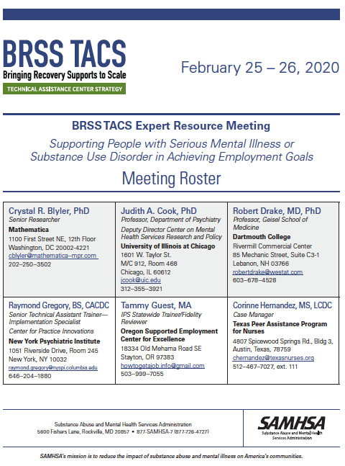
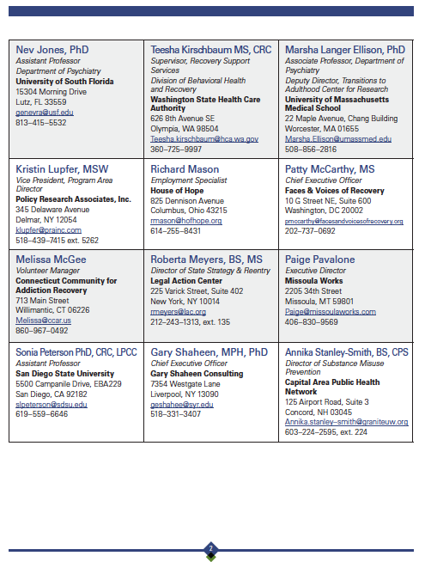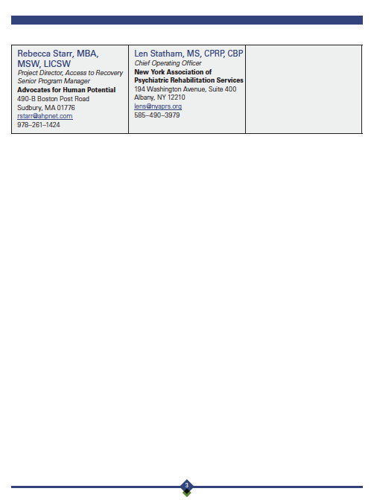

APPENDIX B: expert Panel members’ biographies
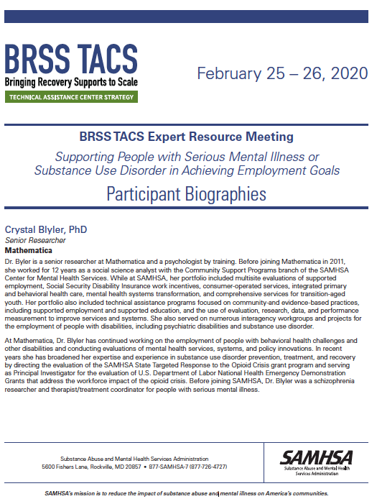
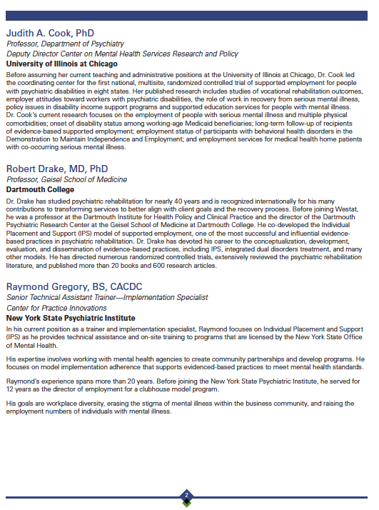

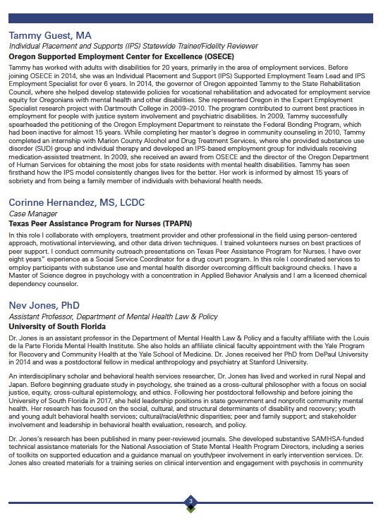
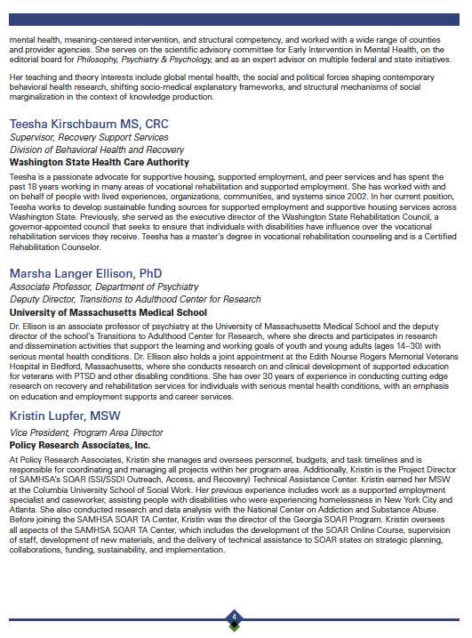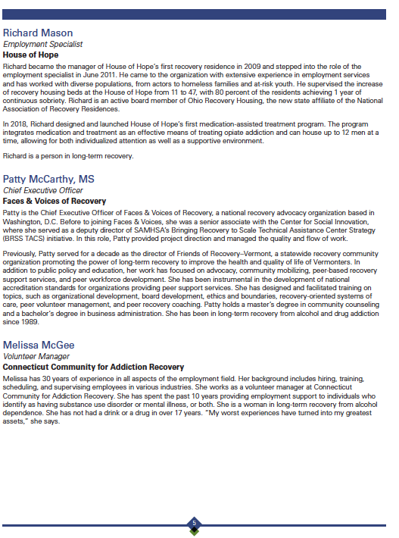

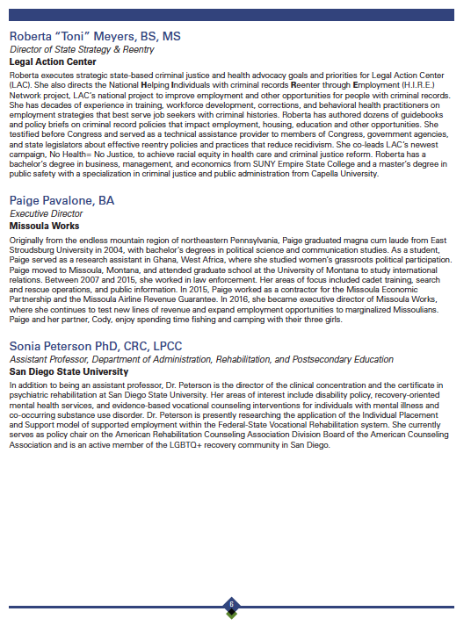

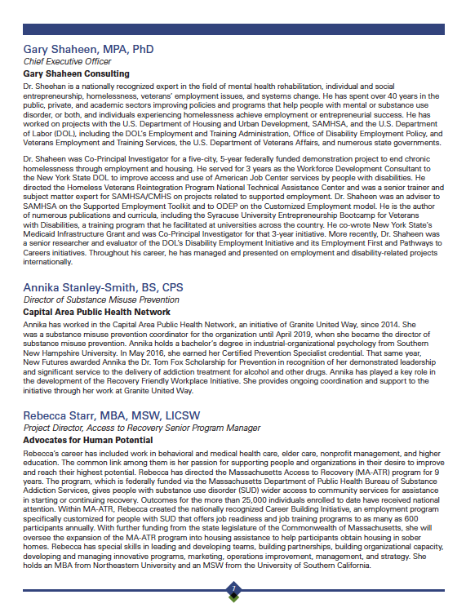

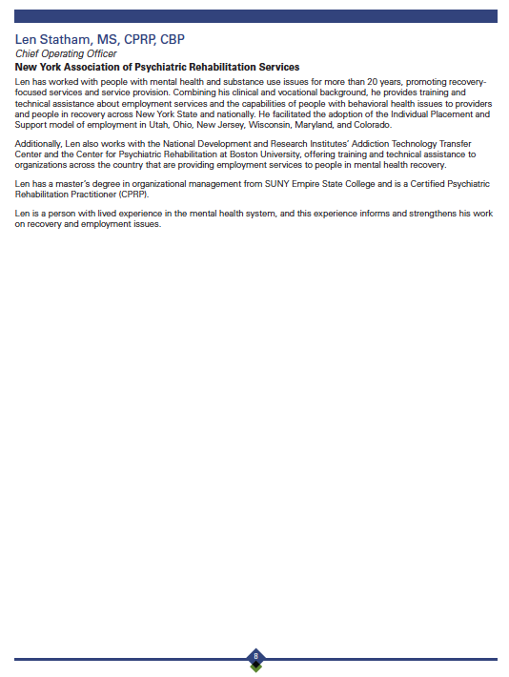

APPENDIX C: MEETING AGENDA
